QUANTITATIVE RISK, SUPPLY CHAIN
AND DISASTER RECOVERY ASSESSMENT
Pampered Pets Digitalisation
Security Risk Management
Executive Summary and Technical Risk Assessment
Quantitative horizon: 12 months | FTA + Monte Carlo | 200,000 iterations
All probabilities are scenario estimates, not observed Pampered Pets failure rates.

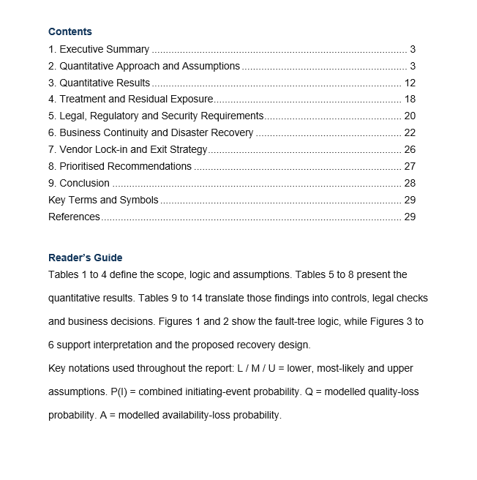

1. Executive Summary
Pampered Pets is extending its operations through international suppliers and automated warehouses, introducing new dependencies across sourcing, transport, storage and digital services. As these connections grow, a failure in one part of the operation could affect others, making it increasingly important to protect the product quality and availability that underpin its premium reputation.
Using FTA and 200,000 Monte Carlo iterations over twelve months, the model suggests that controls could reduce the probability of material quality loss from 11.2% to 2.6%, while availability disruption lasting more than 24 hours could fall from 12.4% to 3.4%. These estimates depend on the scenario assumptions rather than observed company data, but they help identify where improvements may have the greatest effect. The findings support prioritising containment and fallback through supplier assurance, traceability, quarantine, safety stock and alternative routes, alongside a tested recovery design for the online shop. Given the risk of losing the shop premises, that design should be assessed through a complete checkout test demonstrating an RTO below one minute and an RPO of no more than one minute.

2. Quantitative Approach and Assumptions

2.1 Risk identification and model boundary
Internationalisation exposes Pampered Pets to more than delayed deliveries, as a defective ingredient can enter through a supplier, become contaminated during processing, deteriorate in storage or transit, or be released from an automated warehouse without effective checking. Physical disruption, third-party failure, cyber compromise and weak data integrity can also interrupt fulfilment or undermine product release.
Table 1 separates the wider risk pathways from those assigned explicit probability distributions, allowing the quantitative model to focus on two customer-facing outcomes, material product-quality loss and supply unavailability lasting more than 24 hours. Limiting the analysis to these outcomes keeps the model manageable, while recognising that physical, cyber, legal and managerial risks remain relevant to treatment and governance even when they are not quantified.
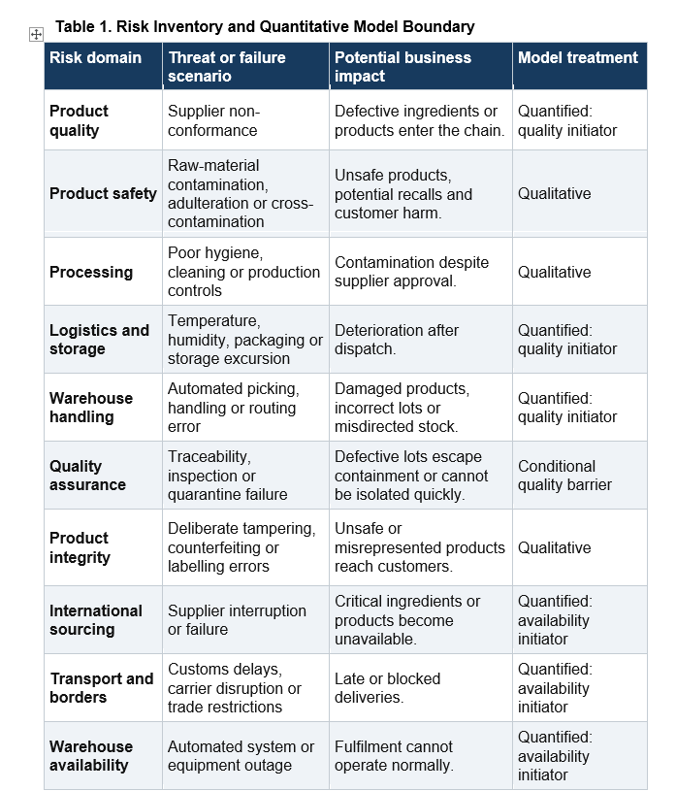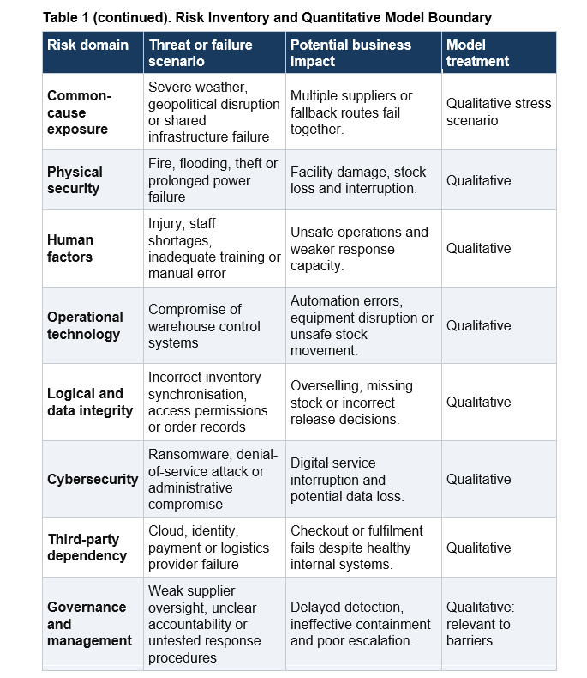
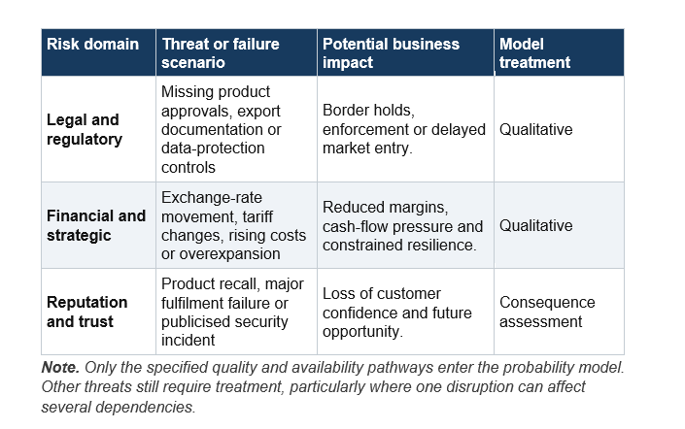

2.2 Method selection and literature synthesis
FTA and Monte Carlo are used together because the case requires probability estimates for losses arising when supply-chain disruptions combine with failed controls. FTA makes these pathways visible, while Monte Carlo examines how uncertain inputs affect the outcomes. Table 2 explains why this combination is more appropriate here than a qualitative matrix or a single deterministic calculation (Acebes Senovilla et al., 2025; Bara, 2025).
However, the choice raises questions about dependency and evidence strength. Aven and Thekdi (2025) emphasise the knowledge behind risk estimates, while Qazi and Khan (2026) use Bayesian networks to represent interconnected risks at country level. Their analysis does not establish dependencies among Pampered Pets’ suppliers, but shared transport infrastructure could undermine the independence assumed here. Bayesian modelling could capture these relationships more fully, although the case lacks credible conditional data. I favour a transparent model whose assumptions can be challenged through sensitivity and robustness testing.

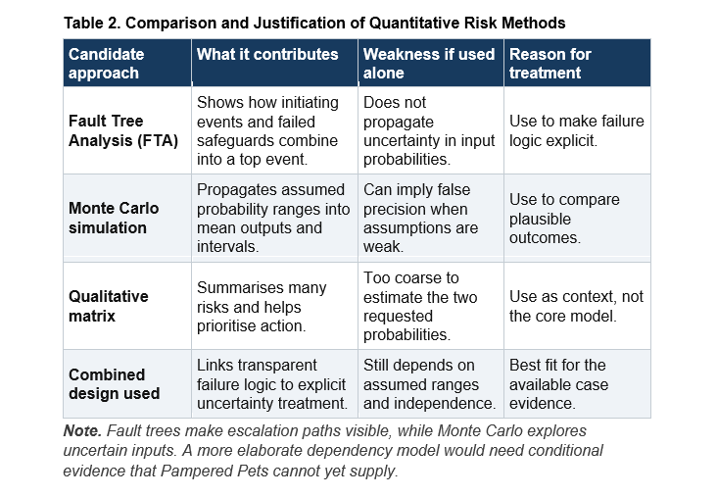

2.3 Model formulation
Figures 1 and 2 show how an initiating event could develop into a material business loss. The quality tree follows supplier, transport and handling failures, while the availability tree follows supplier, logistics and warehouse disruption. In both trees, a customer-facing loss requires not only an initiating event but also failure of the relevant barrier.
Figure 1. Product-quality fault tree. Supplier, transport or warehouse handling failures may initiate a disruption, but the modelled loss also requires detection or containment to fail.
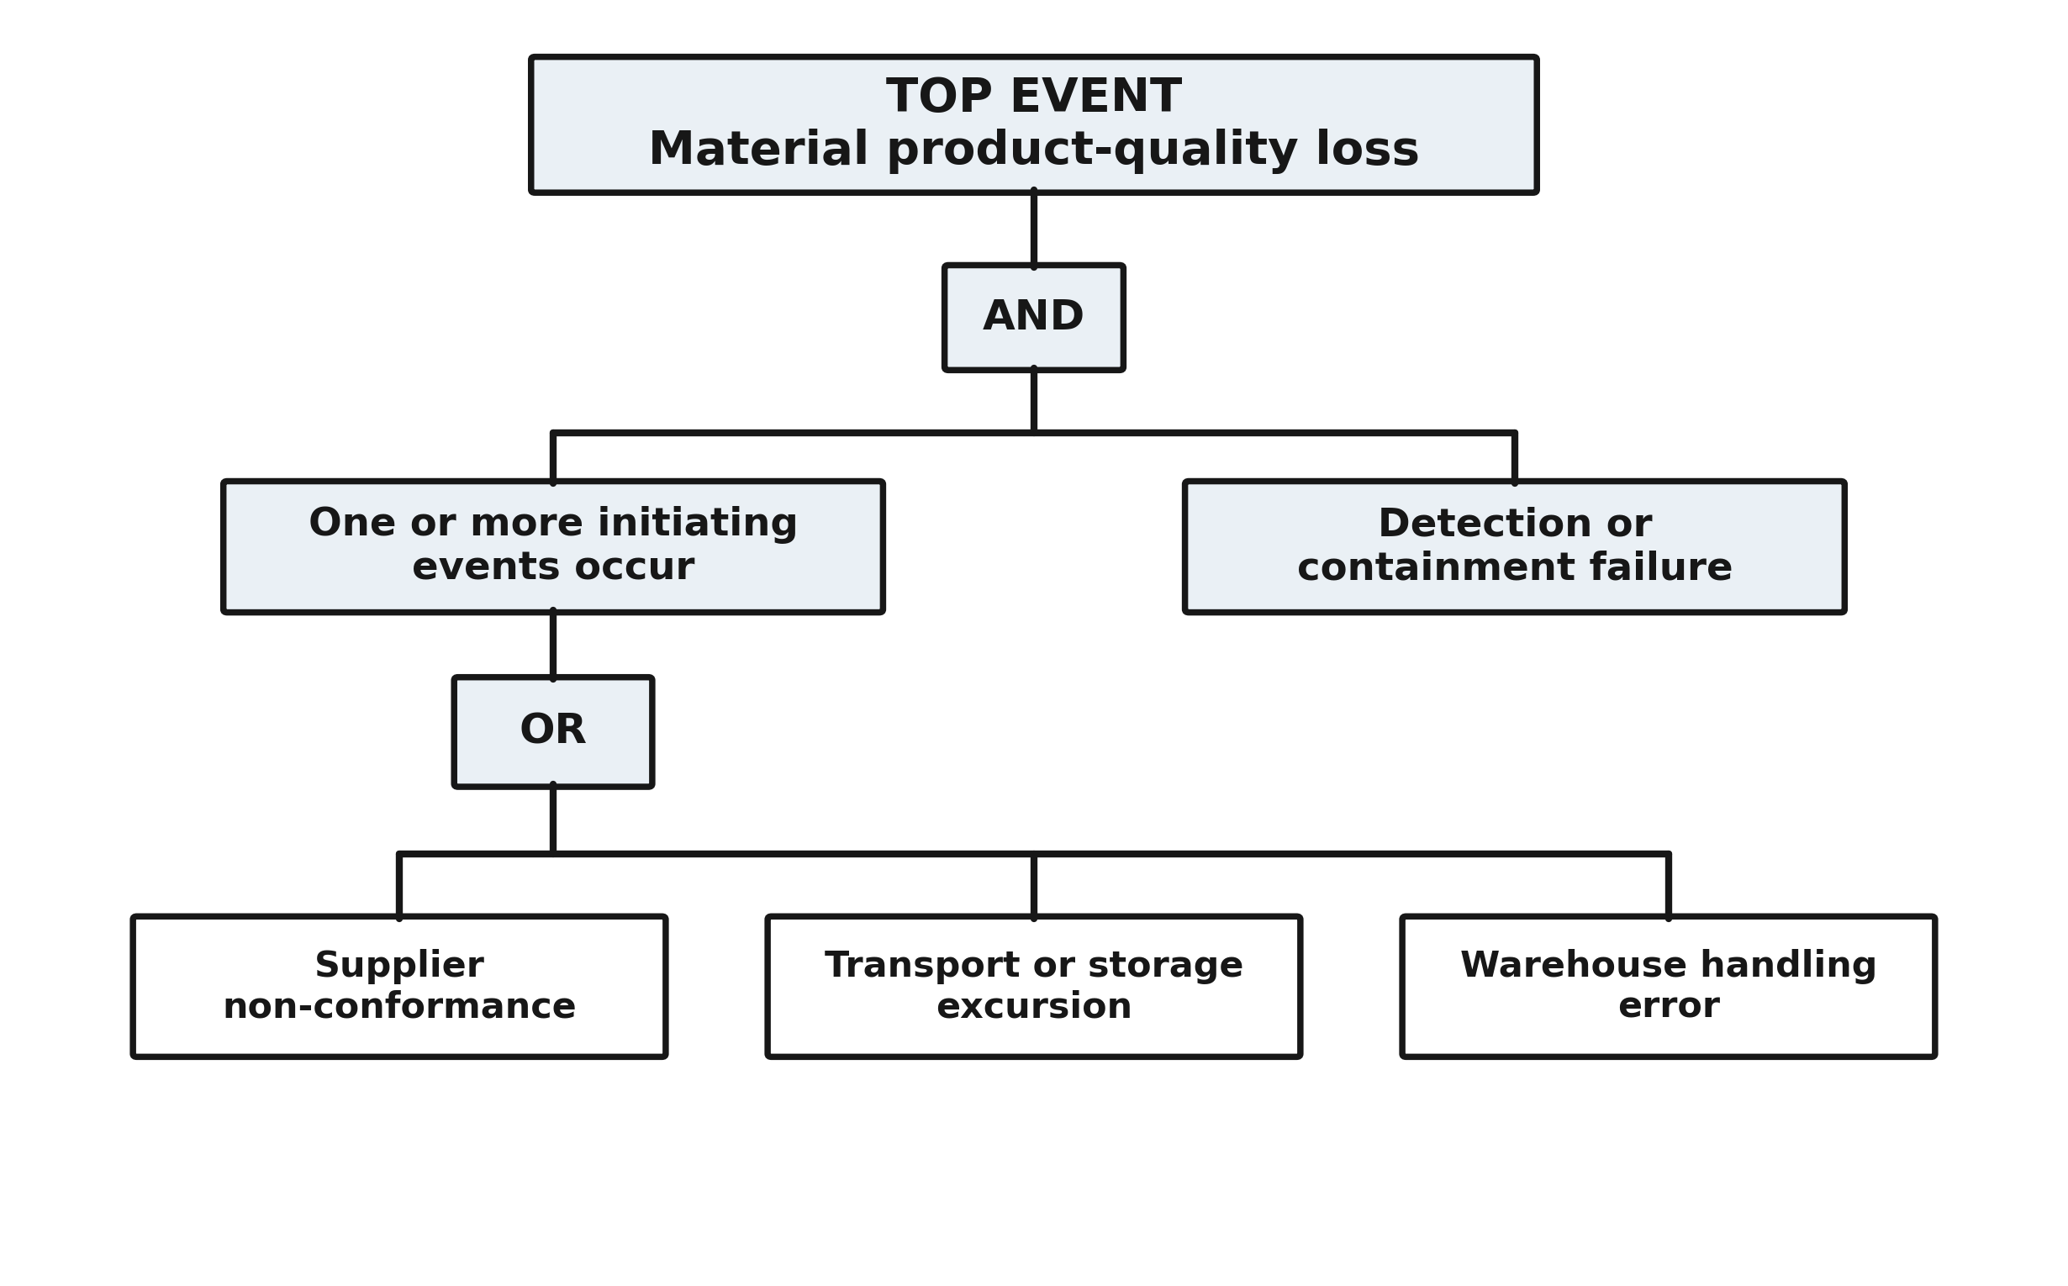
Figure 2. Supply-availability fault tree. Supplier, border or warehouse disruption exceeds the 24-hour materiality threshold only when the relevant continuity fallback also fails.
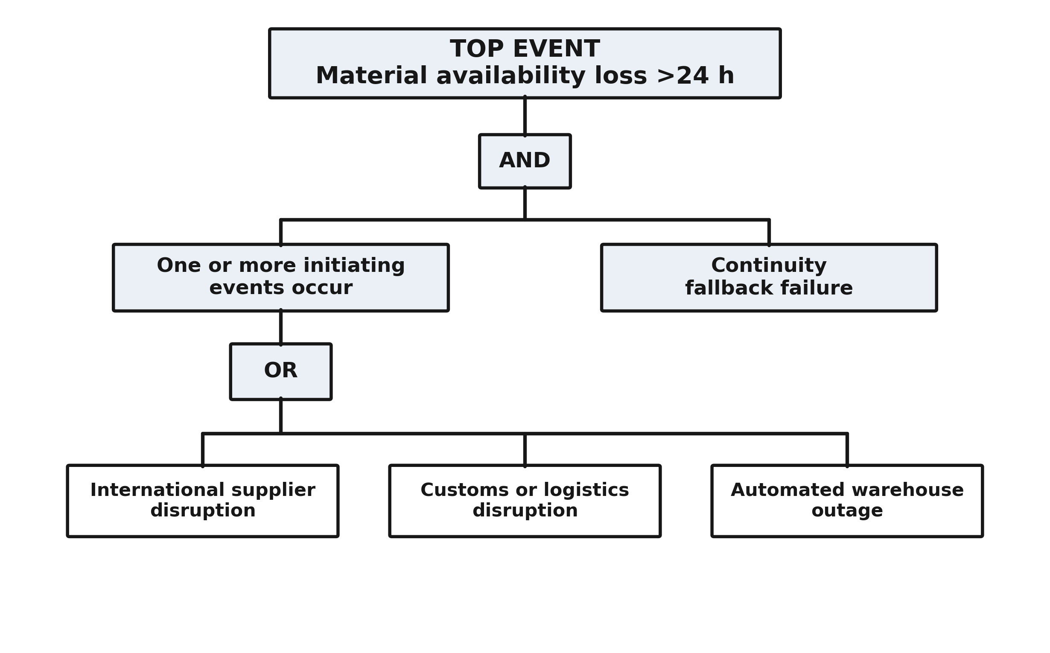
Reading from bottom to top,
OR means any one initiating event can occur.
AND means the top event occurs only when the initiating event is accompanied by failed containment or failed fallback.
Assuming independent initiating events, their combined probability is
P(I) = 1 − [(1 − p1) × (1 − p2) × (1 − p3)].
Quality is then modelled as Q = P(I) × P(detection or containment failure | I), and availability as A = P(I) × P(fallback failure | I).
One conditional barrier parameter is used per tree because the case does not provide event-specific barrier-performance data.

2.4 Assumptions, evidence and knowledge strength
Tables 3 and 4 suggest that strengthening containment and fallback may offer greater protection than trying to eliminate international supply disruptions. Supplier and logistics risks would remain even after the proposed controls, although effective inspection, quarantine and alternative fulfilment could prevent these problems from reaching customers. Much of the modelled improvement depends on containment failure falling from 62% to 16% and fallback failure from 55% to 15%. I consider these sensible priorities, particularly given the material and hygiene risks highlighted by FSA (2026), but their effectiveness would need to be demonstrated. Mock recalls, alternative-route exercises and warehouse recovery tests would help establish whether the assumed reductions are achievable. Until these exercises provide that evidence, the post-control probabilities remain planning estimates rather than accepted residual-risk levels.
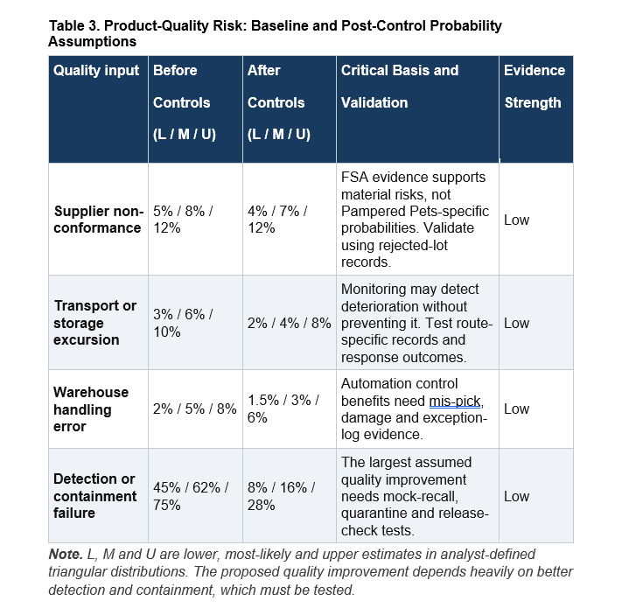

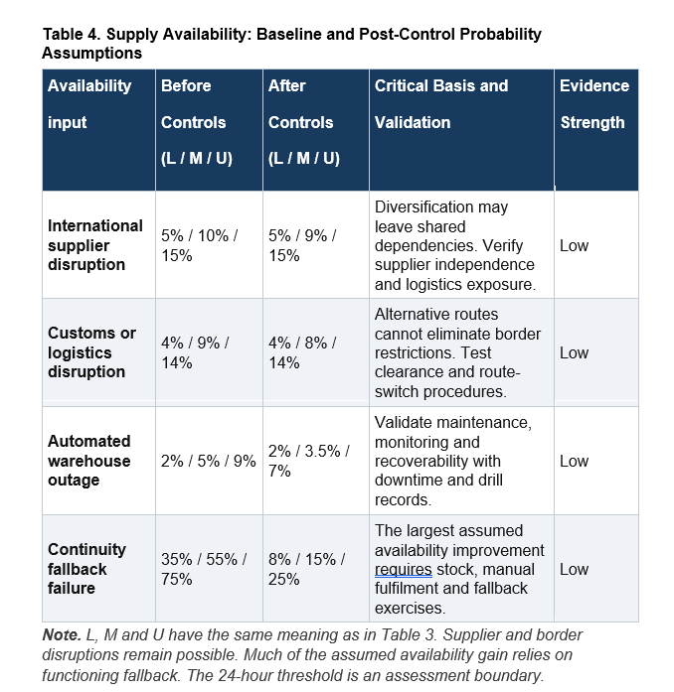

3. Quantitative Results
Tables 5 and 6 show how the assumptions translate into potential business losses. With the proposed controls, mean modelled annual quality-loss probability falls from 11.2% to 2.6%, while supply unavailability lasting more than the assumed 24-hour threshold falls from 12.4% to 3.4 Point calculations use most-likely inputs, while simulation means reflect full triangular distributions.

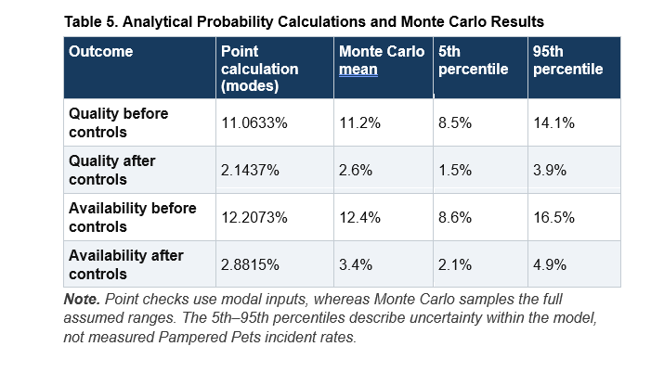
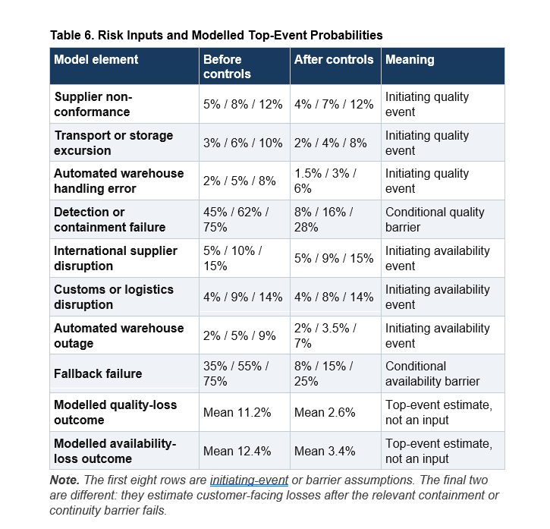
Figures 3 and 4 show lower modelled probabilities after controls, but product quality remains a priority despite its smaller residual estimate. A defective product reaching customers could cause more lasting reputational damage than a delayed order.
Figure 3. Modelled quality-loss probability across uncertain inputs. The lower post-control distribution reflects assumed improvements in containment, not observed reductions in customer incidents.
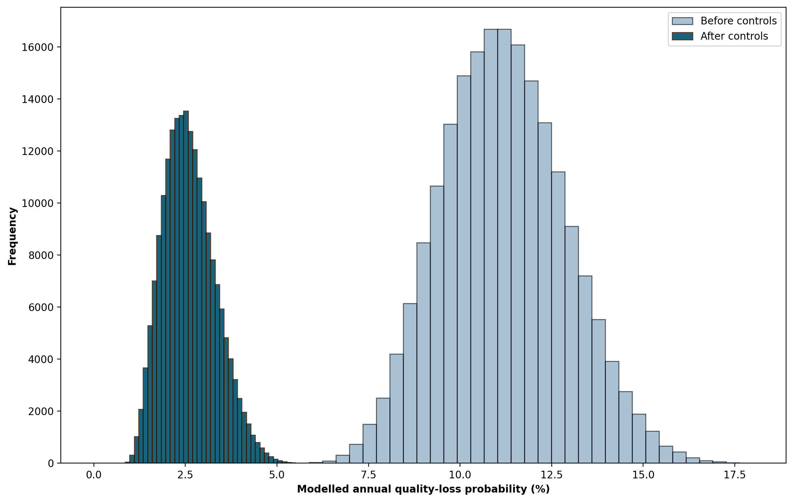
Figure 4. Modelled supply-availability loss across uncertain inputs. The improvement relies heavily on contingency stock, alternative routes and fallback procedures working in practice.
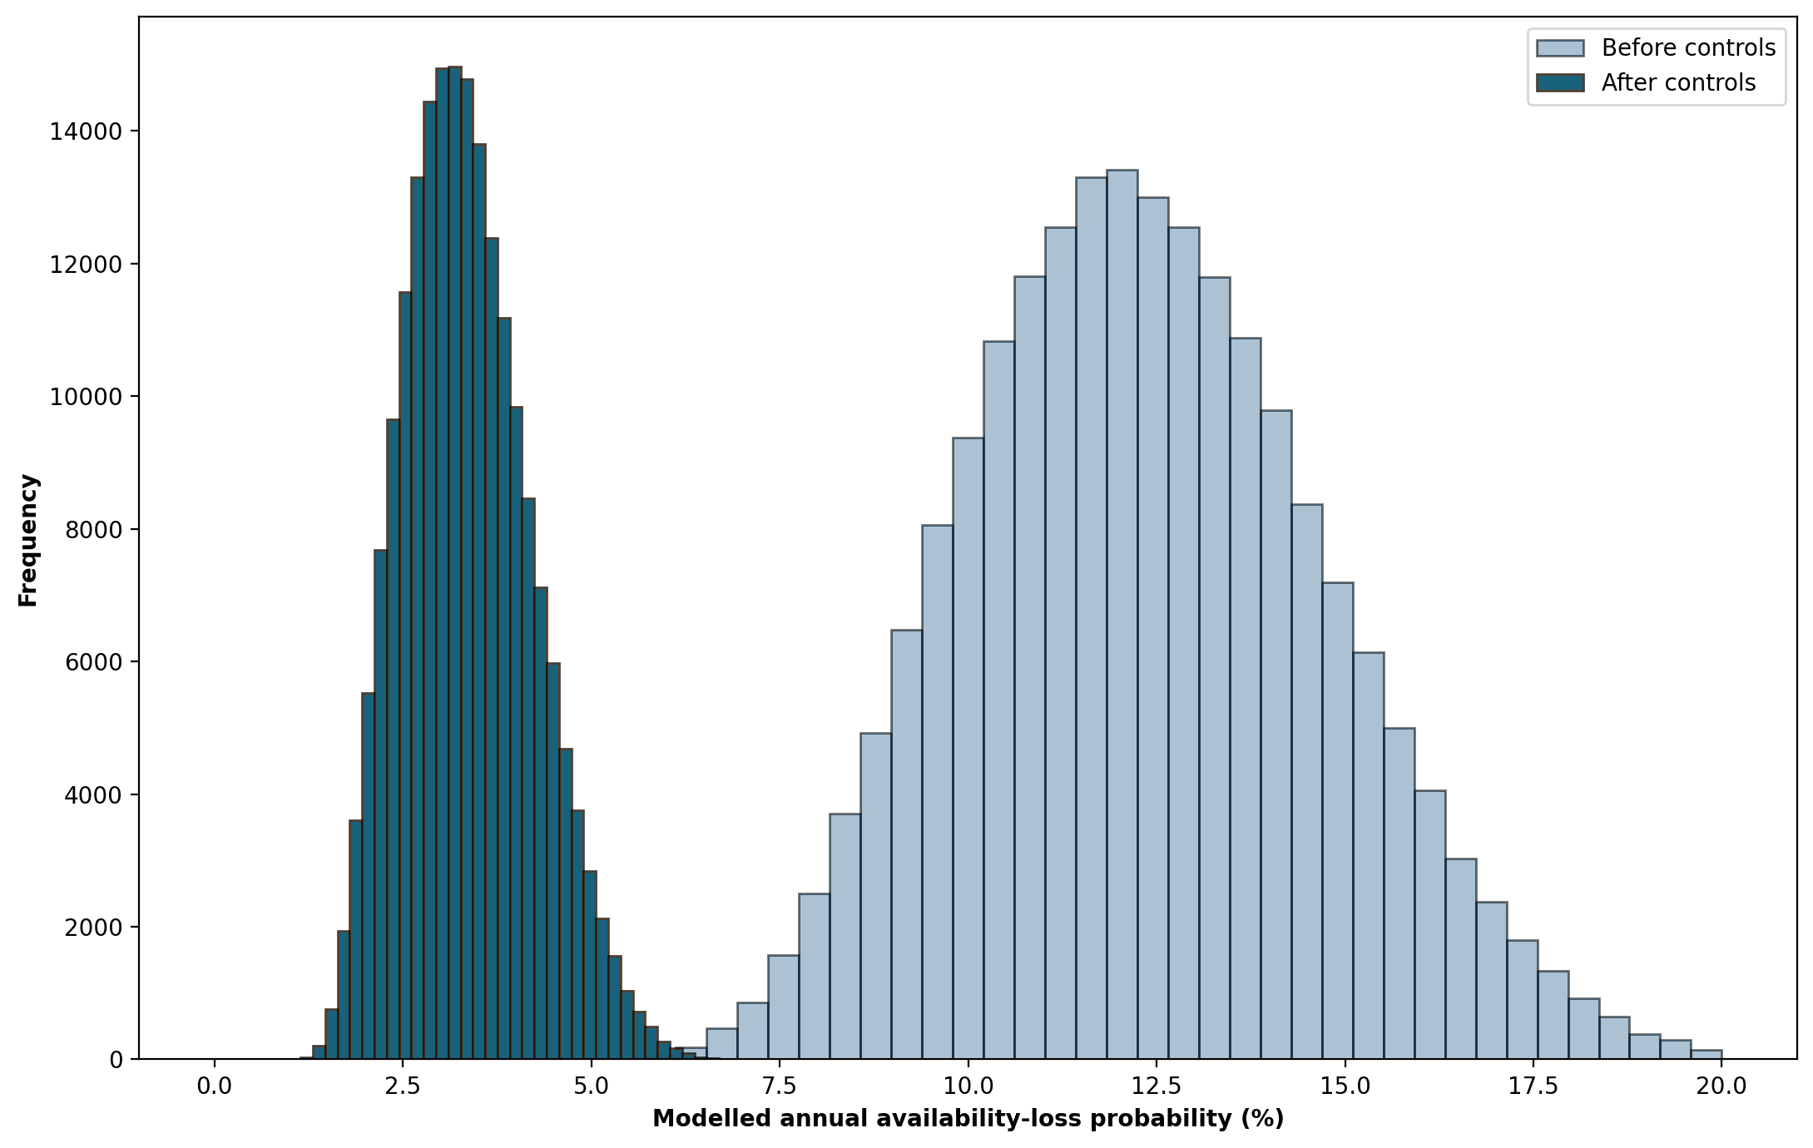
Table 7 and Figure 5 identify containment and fallback as the strongest post-control sensitivity inputs, supporting inspection, quarantine and tested switching arrangements. These correlations show which assumptions drive the estimates, not the reduction any single control will achieve. Table 8 shows numerical convergence by 200,000 iterations, although stable simulation means do not validate the assumptions.
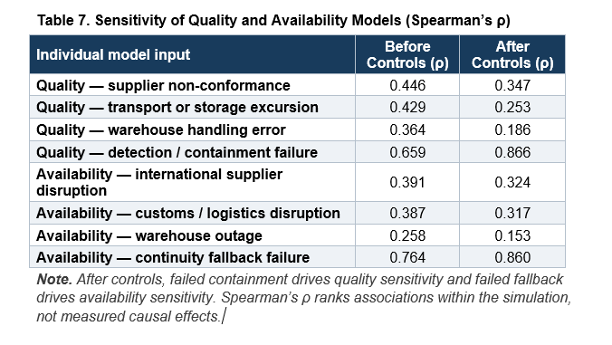
Figure 5. Quality-model sensitivity before and after controls. Containment failure becomes the strongest post-control influence, directing attention towards tested inspection, quarantine and traceability.
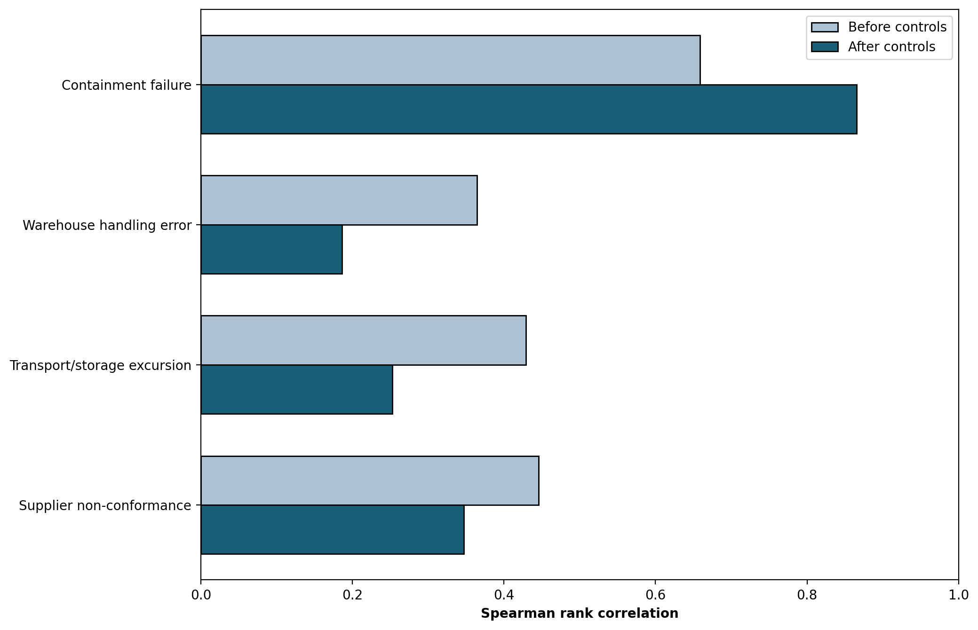
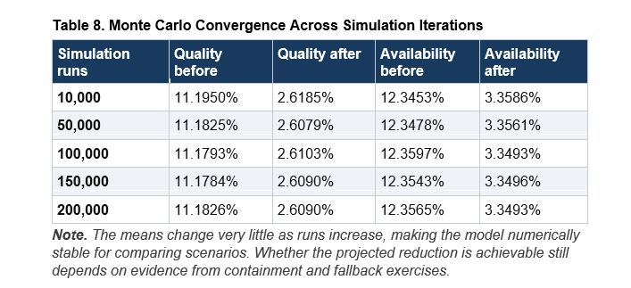
A simple robustness check strengthens the recommendation. Holding the post-control initiating-event modes constant, increasing containment failure from its most-likely 16% to its existing upper assumption of 28% would raise the quality point estimate from 2.14% to about 3.75%. Likewise, increasing fallback failure from 15% to 25% would lift the availability point estimate from 2.88% to about 4.80%. These are not new simulation means. They show how quickly benefits erode if the response controls do not work as intended.

4. Treatment and Residual Exposure
Table 9 prioritises supplier specifications, incoming inspection, lot traceability, quarantine and temperature monitoring. Products meeting specifications at dispatch may still deteriorate during transport or storage, requiring controls throughout the chain.
For availability, another supplier offers limited protection if Pampered Pets cannot switch routes or fulfil orders when its normal warehouse is unavailable. Safety stock, route alternatives and manual procedures therefore need to be tested together. Table 10 extends this point beyond the two quantified top events. A compromised stock record could undermine both product release and fulfilment, while payment failure could stop trading even when products remain physically available. Data integrity, third-party dependency and governance capability remain part of the same residual-risk picture.
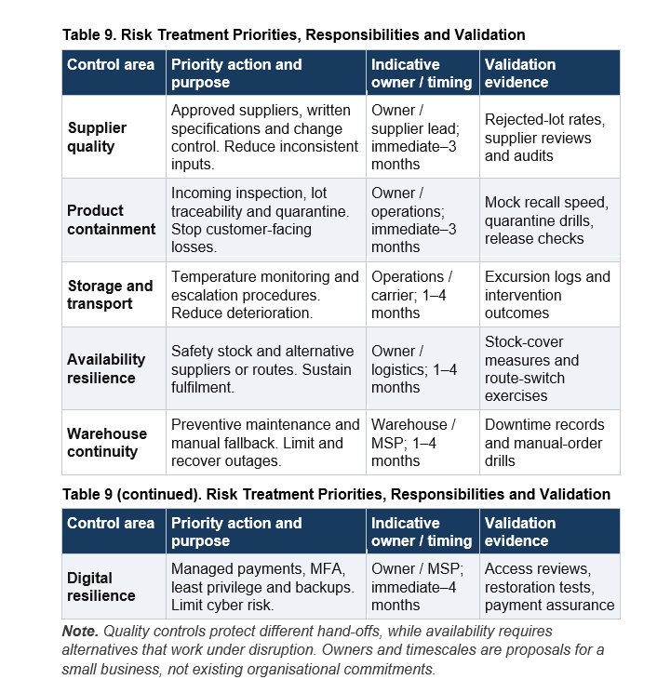

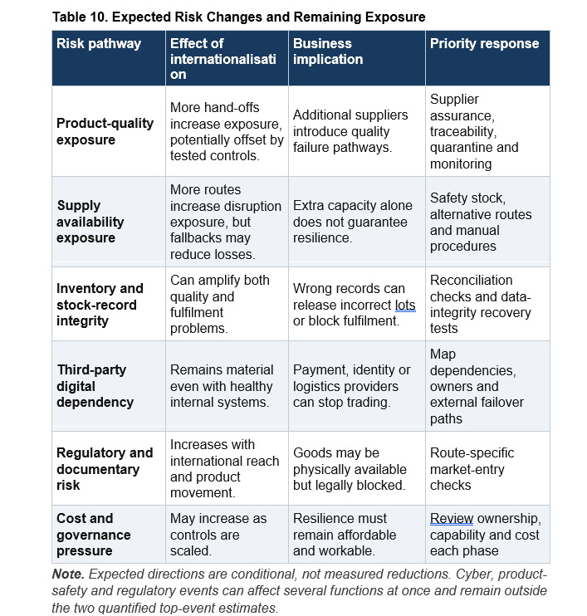

5. Legal, Regulatory and Security Requirements
Controlling disruptions addresses only part of the expansion decision, since goods may arrive on time yet remain held at a border because of missing documents or approvals. This could undermine alternative suppliers and safety stock, particularly if automated stock systems release goods before clearance. Pet-food retail may be exempt from feed-business registration, but importing, storing or manufacturing feed can require different registration or approval depending on the activity and route (FSA, 2017; GOV.UK, 2026a, 2026b). Checking these obligations before entering a market and linking clearance to warehouse release procedures would reduce the risk of legally blocked stock being offered for sale.
A functioning checkout could still expose personal data, while payment-provider failures or inaccessible records could interrupt trading. UK GDPR requires appropriate security and timely recovery of access, and the Data (Use and Access) Act 2025 amends rather than replaces this framework (DSIT, 2025; ICO, n.d.). Failure to address these duties could increase recovery costs, attract regulatory scrutiny and weaken customer confidence. Table 11 distinguishes legal obligations from voluntary guidance, covering exposures that the quantitative model cannot fully capture.

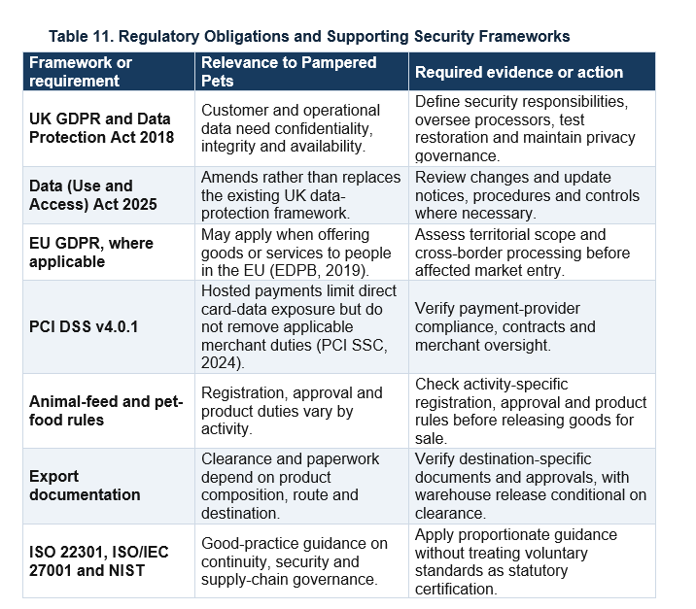6. Business Continuity and Disaster Recovery

6.1 BIA and mission thread
The availability model defines a material supply interruption as lasting more than 24 hours, while the online shop must operate 24/7/365 with recovery below one minute and no more than one minute of data loss. A business impact analysis should recognise these different recovery priorities. Losing the shop premises could interrupt access to stock records, staff systems or warehouse connections while the website continues accepting payments, leaving customers with confirmed orders that Pampered Pets cannot reliably fulfil.
Drawing on Corbari et al. (2024), the mission-thread analysis follows the complete transaction from identity and stock validation through payment, order commitment and confirmation, as mapped in Table 12. Physical fulfilment may require separate contingency arrangements, but online orders should remain dependent on reliable stock information and a workable delivery route. A responsive website offers little reassurance if the business cannot honour the orders it accepts.

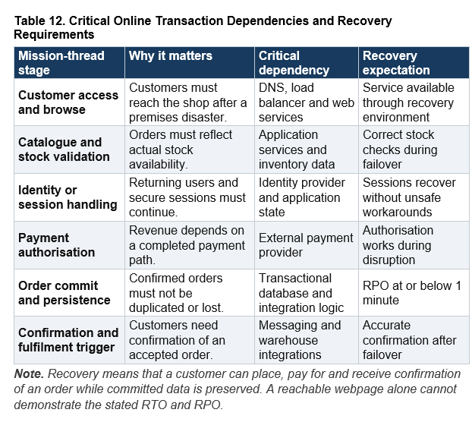6.2 Proposed recovery architecture
Figure 6 presents the proposed Google Cloud design for testing, using Cloud Run services in London and Belgium, a global external Application Load Balancer and health-based routing away from an unhealthy region. A multi-region Spanner configuration offers strongly consistent transactional state (Google Cloud, 2026a, 2026b), although its effectiveness depends on the connections between services.
A payment could succeed while an order write fails, making safe retries and transaction reconciliation important alongside database replication. Identity, stock validation and messaging must also remain accessible without the shop's local network. Testing should examine operating cost, potential write latency and managed-service dependence before the architecture is treated as a suitable long-term choice.
Figure 6. Proposed multi-region disaster recovery design. Regional cloud resilience supports the solution, but acceptance depends on a completed checkout after premises or regional failure.
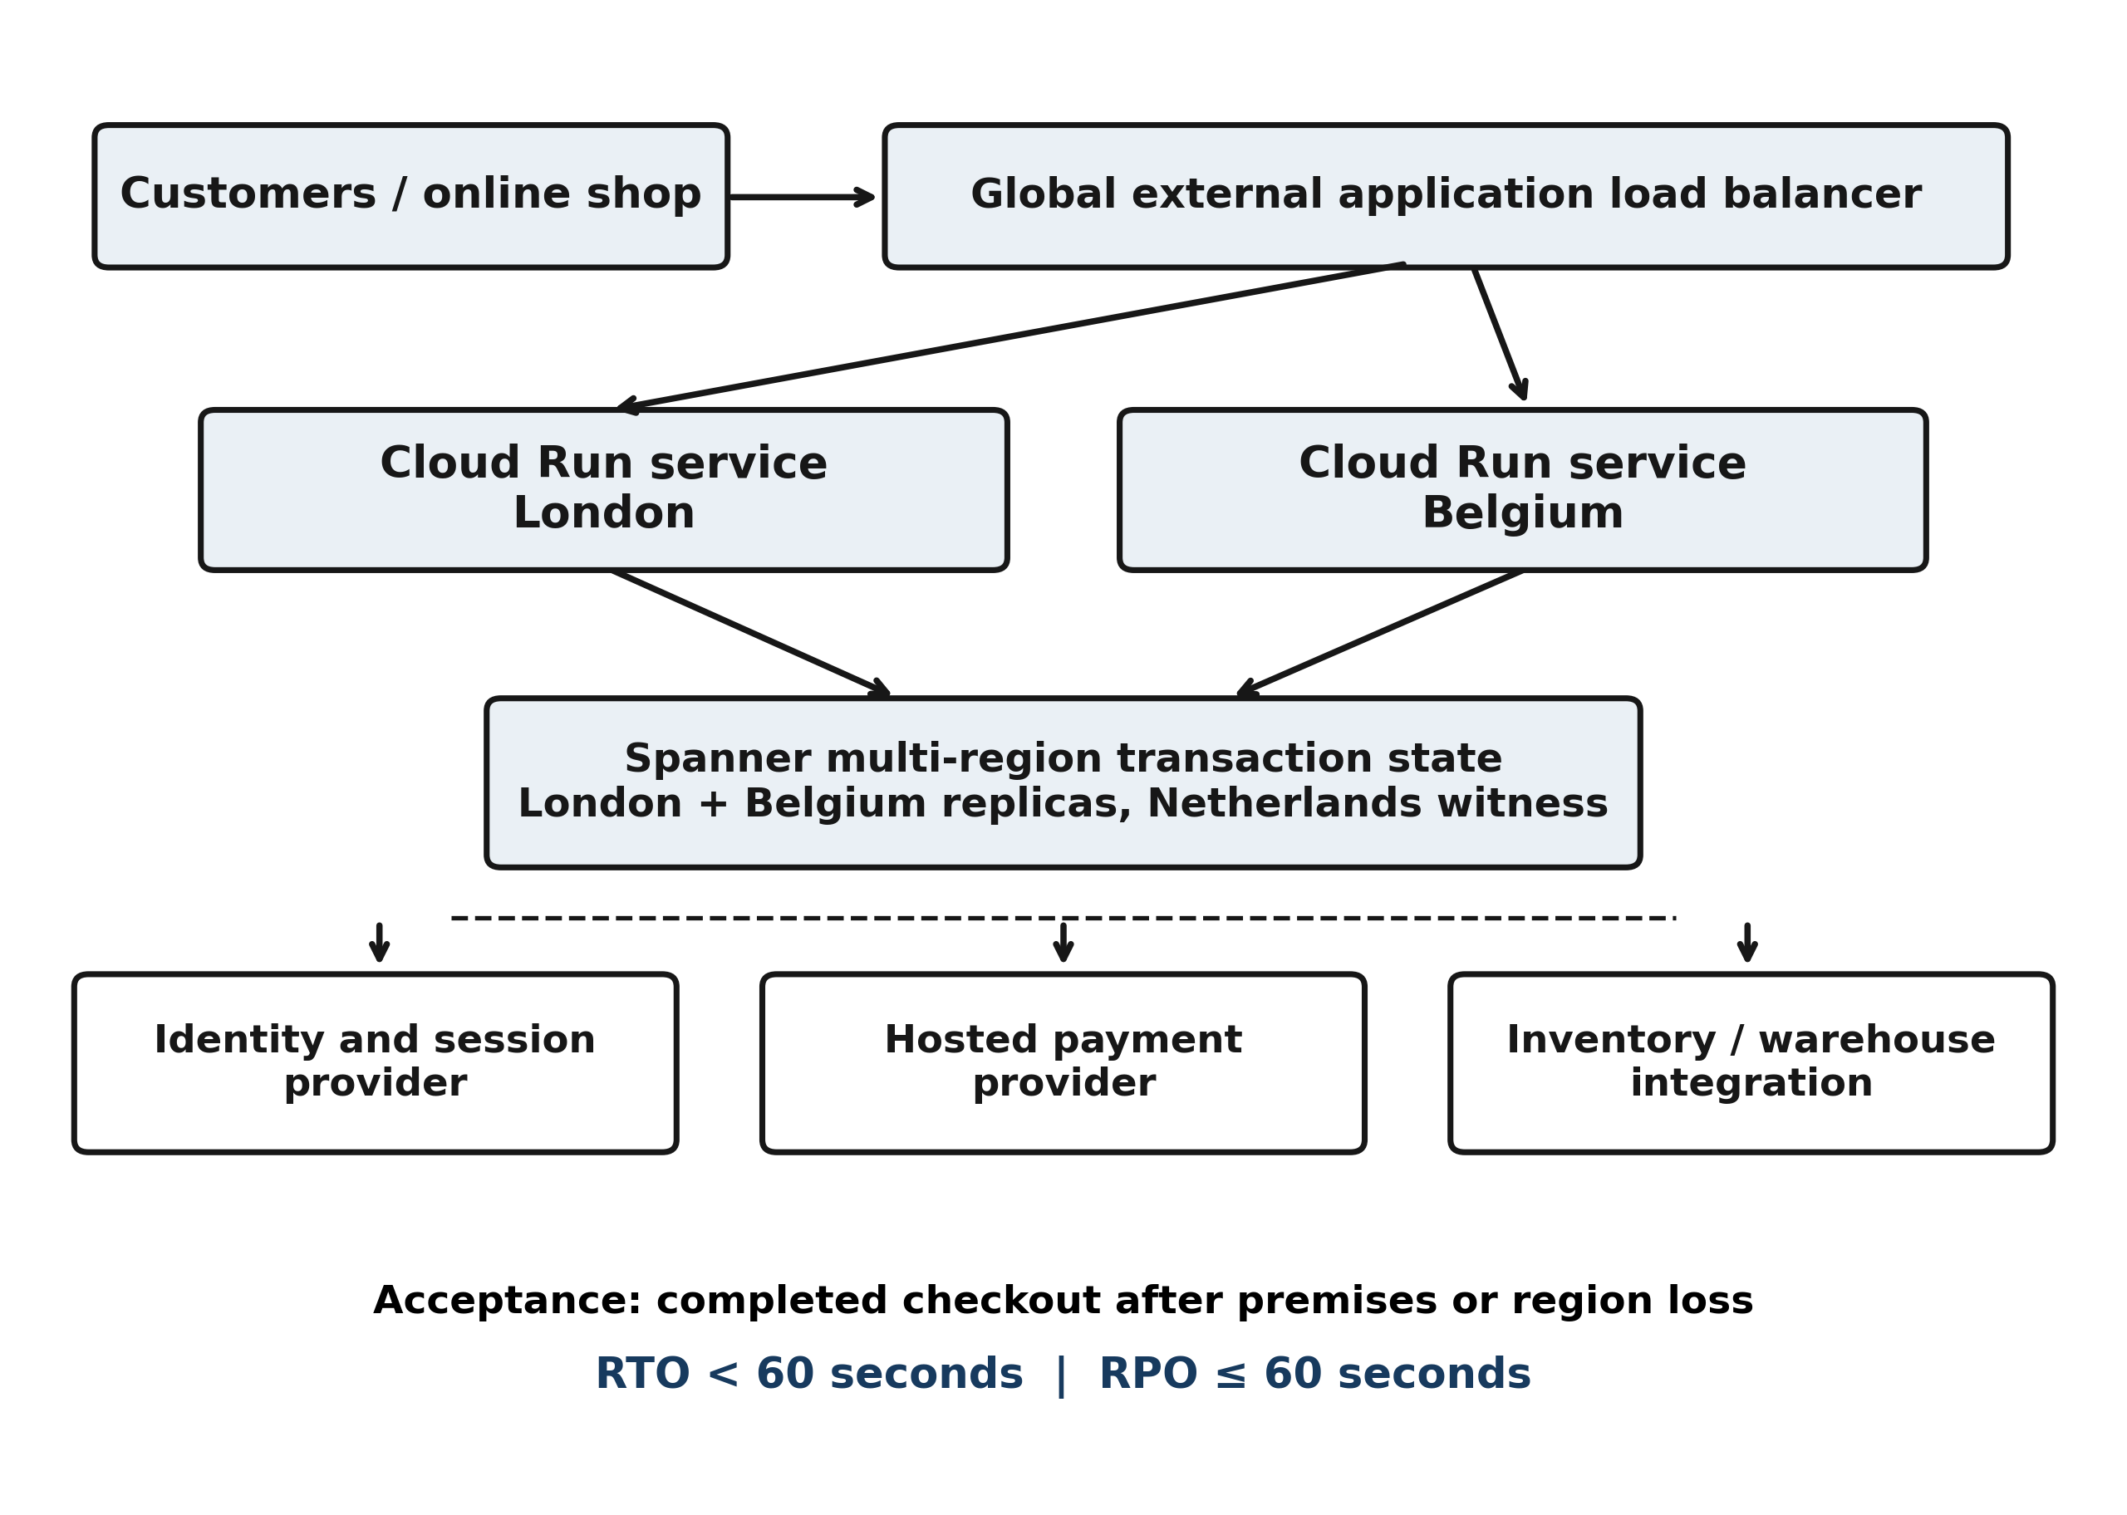

6.3 RTO and RPO acceptance testing
Acceptance testing should cover both the premises disaster specified in the case and the loss of a cloud region. RTO should be measured from the disruption until a customer successfully completes checkout, including authentication, payment and confirmation. RPO should be checked against the last acknowledged transactions, reconciling recovered records to identify missing or duplicated orders (NCSC, n.d.-a).
Tests should also cover existing sessions, stock updates and periods of higher demand, since a successful demonstration under light traffic may conceal operational weaknesses. The proposed design should demonstrate RTO below 60 seconds and RPO no greater than 60 seconds before launch. Separately recoverable backups remain necessary for corruption or ransomware, as replication can preserve damaging changes. Failed exercises should inform revised procedures and further testing.

6.4 Platform comparison
Table 13 retains AWS as a credible alternative, while Azure needs closer assessment of its proposed transactional consistency design (AWS, n.d.-a, n.d.-b; Microsoft, 2026). Google Cloud remains the provisional preference because its regional routing and consistent data layer suit the recovery path, although the providers’ specifications cannot demonstrate sub-minute checkout recovery.
The proposed architecture could reduce dependence on the shop premises, although its costs and technical demands may be difficult for a small retailer to sustain. A final investment decision should follow comparable failure tests, cost estimates and an assessment of available support, with recovery benefits weighed against the continuing burden.
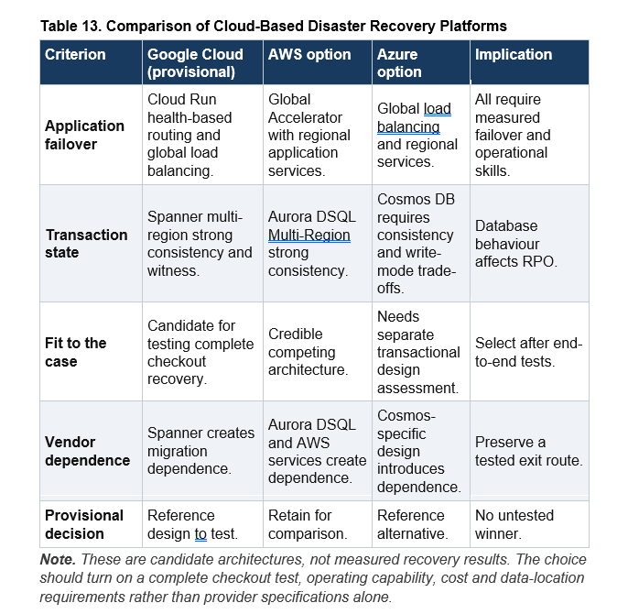

7. Vendor Lock-in and Exit Strategy
A multi-region transactional design inevitably creates some dependence on a cloud provider's interfaces, operating model and pricing. A measured degree of lock-in may be justified if it helps meet the one-minute recovery objective. The better response is not to add a second cloud by default, which may introduce new failure paths, but to require exportable data, documented interfaces, portable application components where practical and contractual migration support. Those measures become meaningful when Pampered Pets can extract and restore its records in an exercise, rather than merely when portability appears in a contract (Alhosban et al., 2024; NCSC, n.d.-b).

8. Prioritised Recommendations
Table 14 sets out evidence for phased expansion, covering supplier assurance, fulfilment, regulatory clearance and tested online recovery. Further growth should follow demonstrated control effectiveness.

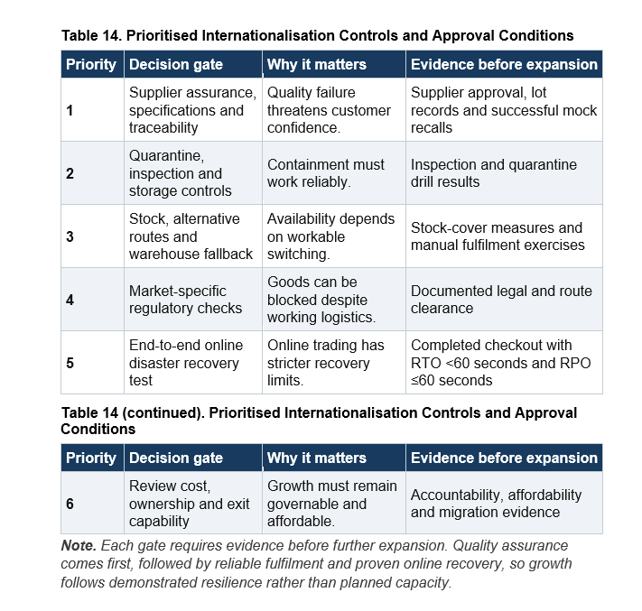

9. Conclusion
I would support internationalisation in stages, with the model offering stronger grounds for prioritising controls than for predicting actual losses. The reductions in quality and availability risk depend heavily on containment and fallback performing as assumed, while shared logistics failures could weaken several suppliers at once. Goods may also arrive on time yet remain legally unavailable, and failures in payment or stock records could interrupt trading beyond the model’s two outcomes. Rejected-lot records, mock recalls and route-switch exercises would provide evidence for revisiting the assumptions as operations expand. The online shop needs its own evidence, particularly a completed checkout following premises or regional failure within the stated recovery limits. If these arrangements prove unreliable or unaffordable, further expansion should wait. Protecting the product promise requires evidence that Pampered Pets can sustain its service as well as increase its capacity.

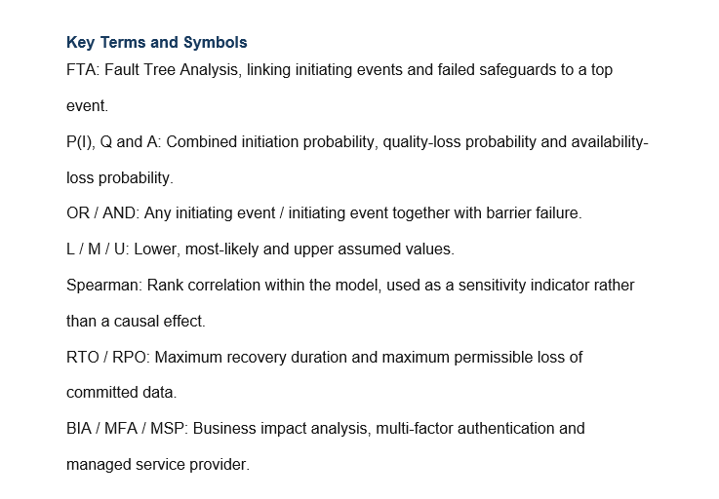

References
Acebes Senovilla, F., González Varona, J.M., Pajares Gutiérrez, J. and López Paredes, A. (2025) ‘Simulación Monte Carlo como herramienta para priorizar los riesgos de los proyectos’, Dirección y Organización, 85, pp. 43–56. https://doi.org/10.37610/85.689.
Alhosban, A., Pesingu, S. and Kalyanam, K. (2024) ‘CVL: A Cloud Vendor Lock-In Prediction Framework’, Mathematics, 12(3), 387. https://doi.org/10.3390/math12030387.
Aven, T. and Thekdi, S. (2025) Risk Science: An Introduction. 2nd edn. Abingdon: Routledge.
AWS (n.d.-a) What is Amazon Aurora DSQL? Available at: https://docs.aws.amazon.com/aurora-dsql/latest/userguide/what-is-aurora-dsql.html (Accessed: 8 October 2026).
AWS (n.d.-b) How AWS Global Accelerator works. Available at: https://docs.aws.amazon.com/global-accelerator/latest/dg/introduction-how-it-works.html (Accessed: 8 October 2026).
Bara, M. (2025) ‘Enhanced Monte Carlo simulation for project risk analysis: integrating cost and schedule impacts with time-shifted risks and dependency modeling’, Applied Operations and Analytics, 1(1), pp. 1–15. https://doi.org/10.1080/29966892.2025.2552675.
Corbari, G.I., Khatod, N., Popiak, J.F. and Sinclair, P. (2024) ‘Mission Thread Analysis: Establishing a Common Framework in a Multi-discipline Domain to Enhance Defensive Cyberspace Operations’, The Cyber Defense Review, 9(1), pp. 37–54.
Department for Science, Innovation and Technology (DSIT) (2025) Data (Use and Access) Act 2025: data protection and privacy changes. GOV.UK. Available at: https://www.gov.uk/guidance/data-use-and-access-act-2025-data-protection-and-privacy-changes (Accessed: 8 October 2026).
European Data Protection Board (EDPB) (2019) Guidelines 3/2018 on the territorial scope of the GDPR (Article 3). Available at: https://www.edpb.europa.eu/our-work-tools/our-documents/guidelines/guidelines-32018-territorial-scope-gdpr-article-3-version_en (Accessed: 8 October 2026).
Food Standards Agency (FSA) (2017) Starting an animal feed business. GOV.UK. Available at: https://www.gov.uk/government/publications/starting-an-animal-feed-business/starting-an-animal-feed-business (Accessed: 10 October 2026).
Food Standards Agency (FSA) (2026) Root cause analysis (RCA): animal feeds and pet foods. GOV.UK. Available at: https://www.gov.uk/guidance/rootcauseanalysis-rcaanimal-feeds-and-pet-foods (Accessed: 8 October 2026).
Google Cloud (2026a) Automate cross-region failover with Cloud Run service health. Available at: https://docs.cloud.google.com/run/docs/configuring/configure-service-health (Accessed: 8 October 2026).
Google Cloud (2026b) Regional, dual-region, and multi-region configurations. Spanner documentation. Available at: https://docs.cloud.google.com/spanner/docs/instance-configurations (Accessed: 8 October 2026).
GOV.UK (2026a) Register an animal feed business. Available at: https://www.gov.uk/register-an-animal-feed-business (Accessed: 8 October 2026).
GOV.UK (2026b) Export or move animal feed or pet food. Available at: https://www.gov.uk/guidance/export-food-for-animals-special-rules (Accessed: 8 October 2026).
Information Commissioner’s Office (ICO) (n.d.) Security outcomes. Available at: https://ico.org.uk/for-organisations/uk-gdpr-guidance-and-resources/security/a-guide-to-data-security/security-outcomes/ (Accessed: 8 October 2026).
International Organization for Standardization (ISO) (2019) ISO 22301:2019 Security and resilience: Business continuity management systems – Requirements. Geneva: ISO. With Amendment 1:2024.
International Organization for Standardization (ISO) (2022) ISO/IEC 27001:2022 Information security, cybersecurity and privacy protection: Information security management systems – Requirements. Geneva: ISO.
Microsoft (2026) Consistency level choices – Azure Cosmos DB. Microsoft Learn. Available at: https://learn.microsoft.com/en-us/azure/cosmos-db/consistency-levels (Accessed: 8 October 2026).
National Cyber Security Centre (NCSC) (n.d.-a) Principle 2: Asset protection and resilience. Available at: https://www.ncsc.gov.uk/collection/cloud/the-cloud-security-principles/principle-2-asset-protection-and-resilience (Accessed: 8 October 2026).
National Cyber Security Centre (NCSC) (n.d.-b) Service and deployment models. Available at: https://www.ncsc.gov.uk/collection/cloud/understanding-cloud-services/service-and-deployment-models (Accessed: 8 October 2026).
National Institute of Standards and Technology (NIST) (2024) Cybersecurity Supply Chain Risk Management Practices for Systems and Organizations. SP 800-161 Rev. 1 Update 1. Gaithersburg, MD: NIST. Available at: https://csrc.nist.gov/pubs/sp/800/161/r1/upd1/final (Accessed: 8 October 2026).
PCI Security Standards Council (PCI SSC) (2024) Payment Card Industry Data Security Standard (PCI DSS), v4.0.1. Available at: https://www.pcisecuritystandards.org/standards/pci-dss/ (Accessed: 8 October 2026).
Qazi, A. and Khan, S. (2026) 'Mapping the landscape of global supply chain risk: insights from Bayesian networks of interconnected risk indices and indicators', Benchmarking: An International Journal, 33(10), pp. 3065–3095. https://doi.org/10.1108/BIJ-01-2025-0051.

